Student Wellbeing Policy

Anson Street School ensures that student wellbeing is a priority throughout all teaching and learning activities and experiences across the entire school community.

Anson Street School
Reviewed: February 2021

Purpose

Student Wellbeing is concern for the physical, intellectual, social and emotional development of students and is fundamental to our way of working at Anson Street School.

Our mission, independence through learning is taught through the curriculum and supported by our expectations of being respectful, responsible and safe. Concern for the wellbeing needs of individual students is evident at all times, across the curriculum and throughout the school community.

Student wellbeing programs consider the common needs of students as well as various groups – Aboriginal, ethnic, gender, socio-economic. As well as problem-solving, programs which focus on developmental and preventative aspects of wellbeing.

Outcomes for Students

- Positive self-esteem
- A caring attitude
- Satisfaction from lifelong learning and independence
- Ability to make responsible decisions
- Ability to make informed health and lifestyle decisions
- Development of interpersonal and communication skills
- Development of problem-solving skills

Outcomes will be achieved through:

A happy and safe school where students and staff are secure and respected.

A school in which the wellbeing of students is a priority in all school policies, programs and practices.

Student learning and participation is the focus of all school endeavours. The learning environment is positive and supportive, fostering student self-esteem. Students feel valued as learners. All students succeed.

A strong partnership in education with students, staff and parents meaningfully engaged in decision making and the life of the school.

School organisation that enhances relationships and demonstrates commitment to fairness and social equity.

Strategies to Promote Good Discipline and Effective Learning

Students learn effectively in a safe, secure environment where staff, students and parents take pride in achievement. A partnership between home and school should aim to create in children positive attitudes to learning and an understanding of appropriate behaviour.

Strategies
- An appropriate curriculum to meet the needs of each student.

- High expectations for learning and behaviour.

- A school ethos that reflects our mission "Respectful, Responsible and Safe".

- Students are encouraged and receive positive feedback through the use of positive education initiatives i.e. kindness, gratitude, curiosity and hope.
- Rewards are used to reinforce appropriate behaviour.

- Class expectations are devised by students and teachers - students are aware of the consequences of breaking expectations. Class discussions enable the review of expectations using a positive student-centred approach.
- Teachers and students model appropriate behaviour.

- Independent and co-operative learning are encouraged.

- Students learn to resolve conflict in a positive way.

- Students are respected and supported in all aspects of their schooling.

- Discussion with parents and guardians regarding their roles and responsibilities in managing behaviour.

Practices to Recognise and Reinforce Student Achievement
The following achievements and behaviours are to be acknowledged and encouraged: Effort in learning Safe conduct
Respectfulness Caring for others
Co-operation Caring for the environment
Achievement Participation in school activities
Honesty Positive attitude
Tolerance Independent learning
Leadership Sporting attitude
Creative thinking Helping others

Strategies

- Encouraging comments
- Consistent and caring behaviour by staff
- Recognition of effort in class and on assemblies
- Positive incident reports
- Merit awards and certificates
- Playground rewards and PBL Shop
- Principal Awards
- Certificates at assembly
- Regular contact with parents
- Various in-class incentives
- Acknowledgement in the school newsletter

Strategies for Dealing with Unacceptable Behaviour
The home and the school have a shared responsibility in setting and maintaining suitable standards of student behaviour. Discipline involves responsible attitudes and appropriate behaviour. It means the development of self-discipline and the ability to accept responsibility for their own actions.

Students and teachers in each class will develop a class behaviour management plan that outlines rewards for positive behaviour and sets firm consistent limits on inappropriate behaviour. Students and staff will also develop a behaviour management plan for the school playground. Students will clearly understand what is expected of them and will choose between appropriate and inappropriate behaviour. Serious behaviour incidents will be recorded on the School Management data base, SENTRAL. In such cases, parents will be informed and their support requested in changing unacceptable behaviour.

Recognition of good behaviour and preventative strategies by teachers will minimise the need for punishment, however, students will accept responsibility for their own actions and understand that punishment is a fair and reasonable consequence of unacceptable actions. Discipline will be viewed as a learning experience where children learn from their mistakes.

Teachers and students have a right to be safe and happy at school. They have a right to be treated fairly and with dignity. Policies, programs and practices challenge discriminatory behaviours and attitudes. Complaints about discrimination, harassment and vilification are referred to the anti-discrimination officer.

Our school condemns violence in all of its forms - physical violence, bullying, threats of violence and intimidation. Weapons, illegal drugs, alcohol or tobacco are prohibited.

Consequences for Unacceptable Behaviour
- Warning – verbal reprimand and reminder of positive behaviour
- Formal caution
- Conference with student
- Timeout (of class activity or in a buddy class)
- Loss of privileges
- Individualised instruction
- Completing school work during recess or lunch times
- Escalation to an executive staff member
- Restitution to repair or compensate for damages caused
- Parent contact – phone call
- Parent contact – interview
- Suspension – with supports in place for a successful return
- Consistent and caring behaviour by staff
- Discussion with parents/carers regarding their roles and responsibilities in managing student behaviour

Three-tiered approach to supporting student wellbeing.

Anson Street school manages whole school wellbeing through a Three Tier framework to deliver evidence-based interventions and supports to students as identified by data.
- Tier 1 – Universal – All students are explicitly taught positive education approaches including PBL expectations, mindfulness, character pillars, Zones of Regulation, by staff that are trained in trauma informed practise and circle of security.
- Tier 2 – Intervention – for the 15-20% of students who need more support then the universal level as identified by PBL data or teacher referrals.
- Tier 3 – Intensive – Complex case management for individual students who have not responded to Tier 2 interventions.

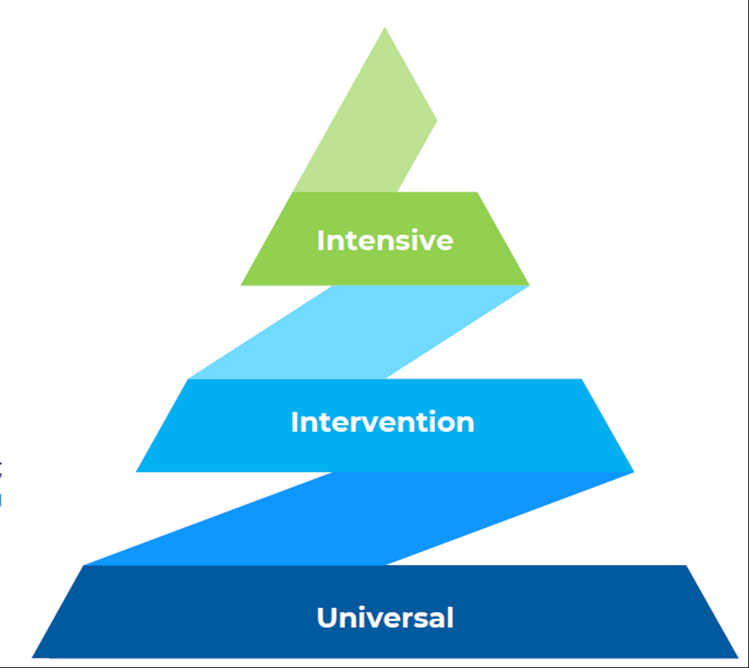

General School Expectations

BE RESPECTFUL
- Listen to staff
- Follow directions
- Use Mr, Mrs, Ms or Miss when speaking to staff
- Use appropriate language and kind words

BE RESPONSIBLE
- Be ready for learning
- Tell a teacher
- Wear school uniform
- Hats off in learning areas
- Take care of belongings and property

BE SAFE
- Be where you need to be
- Keep hands and feet to self

Appendix

